**Jahangirnagar University**

**Experiment Name:** VLAN configuration with Layer 3 switch and Router

**Experiment No. :** 04

**Course Name :**

**Course Code :** CSE­-401

# images

# **Submitted by:**

Name: Sabrina Tajnoor

Roll: 07 Submission Date:

**Introduction:** This experiment shows the way of configuration of VLAN consists of a switch and a router. During configuration a switch each interface is assigned under a VLAN which has both name and number. In this experiment first make a VLAN without router to make the concept clear.

**LAN:** A virtual LAN is any broadcast domain that is partitioned and isolated in a computer network at the data link layer. LAN is the abbreviation for local area network and in this context virtual refers to a physical object recreated and altered by additional logic.

**dot1q function:** IEEE 802**.**1Q is a standard protocol for interconnecting multiple switches and routers and for defining VLAN topologies. Use the encapsulation **dot1q** command in sub-interface range configuration mode to apply a VLAN ID to the sub-interface.

**Objective:** In this lab we will try to send the data packet through routers and set the static connections with command line prompt. Here we used three routers and generic pcs. We also added two extra Ethernet with each of the router so that we connect them each other and they will find the shortest path to send the packets. Now we will see the connections.

**Connections:**

* We have used one router, one switch and 3 VLAN’s using several generic pcs. In CLI (command Line Interface) we put the commands:

Switch>en

Switch#vlan database

Switch(vlan)#vlan 10 name A

VLAN 10 added:

Name: A

Switch(vlan)#vlan 20 name B

VLAN 20 added:

Name: B

Switch(vlan)#vlan 30 name C

VLAN 30 added:

Switch(vlan)#exit

Switch(config)#int Fa0/2

Switch(config-if)#switchport mode access

Switch(config-if)#switchport access vlan 10

Switch(config-if)#int Fa0/3

Switch(config-if)#switchport mode access

Switch(config-if)#switchport access vlan 10

Switch(config-if)#int Fa0/4

Switch(config-if)#switchport mode access

Switch(config-if)#switchport access vlan 20

Switch(config-if)#int Fa0/5

Switch(config-if)#switchport mode access

Switch(config-if)#switchport access vlan 20

Switch(config-if)#int Fa0/6

Switch(config-if)#switchport mode access

Switch(config-if)#switchport access vlan 30

Switch(config-if)#int Fa0/7

Switch(config-if)#switchport mode access

Switch(config-if)#switchport access vlan 30

Switch(config-if)#int Fa0/8

Router>en

Router#conf t

Router(config)#int Fa0/0

Router(config-if)#no shut

Router(config-if)#int Fa0/0.1

Router(config-subif)#encapsulation dot1q 1

Router(config-subif)#ip add 192.168.1.1 255.255.255.0

Router(config-subif)#int Fa0/0.2

Router(config-subif)#encapsulation dot1q 10

Router(config-subif)#ip add 192.168.2.1 255.255.255.0

Router(config-subif)#int Fa0/0.3

Router(config-subif)#encapsulation dot1q 20

Router(config-subif)#ip add 192.168.3.1 255.255.255.0

Router(config-subif)#int Fa0/0.4

Router(config-subif)#ip add 192.168.4.1 255.255.255.0

Router(config-subif)#int Fa0/0.5

Router(config-subif)#encapsulation dot1q 40

Router(config-subif)#ip add 192.168.5.1 255.255.255.0

Router(config-subif)#end

Router#sh ip route

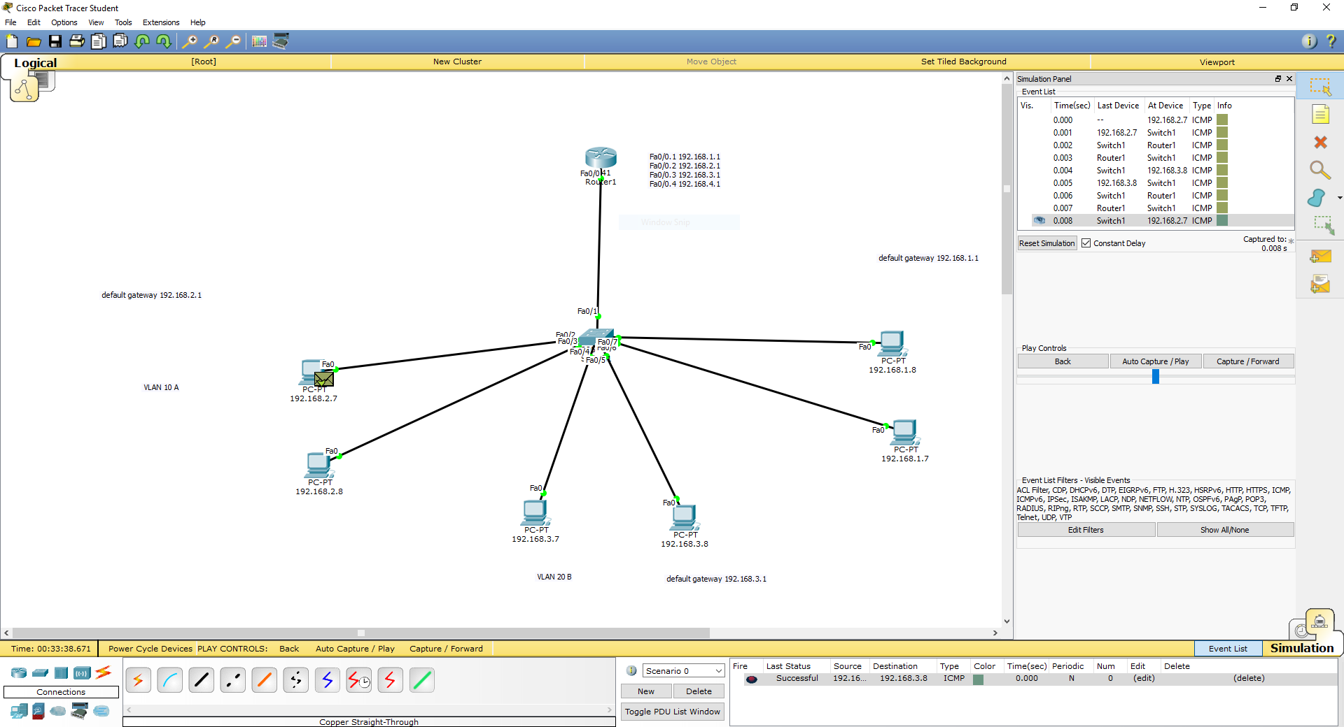

**Fig: Router with three VLANs.**

* We have used one router and 4 VLAN’s and sevearl generic pcs. In CLI (command Line Interface) we put the commands:

Switch>en

Switch#vlan database

Switch(vlan)#vlan 10 name A

VLAN 10 added:

Name: A

Switch(vlan)#vlan 20 name B

VLAN 20 added:

Name: B

Switch(vlan)#vlan 30 name C

VLAN 30 added:

Switch(vlan)#exit

Switch(config)#int Fa0/2

Switch(config-if)#switchport mode access

Switch(config-if)#switchport access vlan 10

Switch(config-if)#int Fa0/3

Switch(config-if)#switchport mode access

Switch(config-if)#switchport access vlan 10

Switch(config-if)#int Fa0/4

Switch(config-if)#switchport mode access

Switch(config-if)#switchport access vlan 20

Switch(config-if)#int Fa0/5

Switch(config-if)#switchport mode access

Switch(config-if)#switchport access vlan 20

Switch(config-if)#int Fa0/6

Switch(config-if)#switchport mode access

Switch(config-if)#switchport access vlan 30

Switch(config-if)#int Fa0/7

Switch(config-if)#switchport mode access

Switch(config-if)#switchport access vlan 30

Switch(config-if)#int Fa0/8

Router>en

Router#conf t

Router(config)#int Fa0/0

Router(config-if)#no shut

Router(config-if)#int Fa0/0.1

Router(config-subif)#encapsulation dot1q 1

Router(config-subif)#ip add 192.168.1.1 255.255.255.0

Router(config-subif)#int Fa0/0.2

Router(config-subif)#encapsulation dot1q 10

Router(config-subif)#ip add 192.168.2.1 255.255.255.0

Router(config-subif)#int Fa0/0.3

Router(config-subif)#encapsulation dot1q 20

Router(config-subif)#ip add 192.168.3.1 255.255.255.0

Router(config-subif)#int Fa0/0.4

Router(config-subif)#ip add 192.168.4.1 255.255.255.0

Router(config-subif)#int Fa0/0.5

Router(config-subif)#encapsulation dot1q 40

Router(config-subif)#ip add 192.168.5.1 255.255.255.0

Router(config-subif)#end

Router#sh ip route

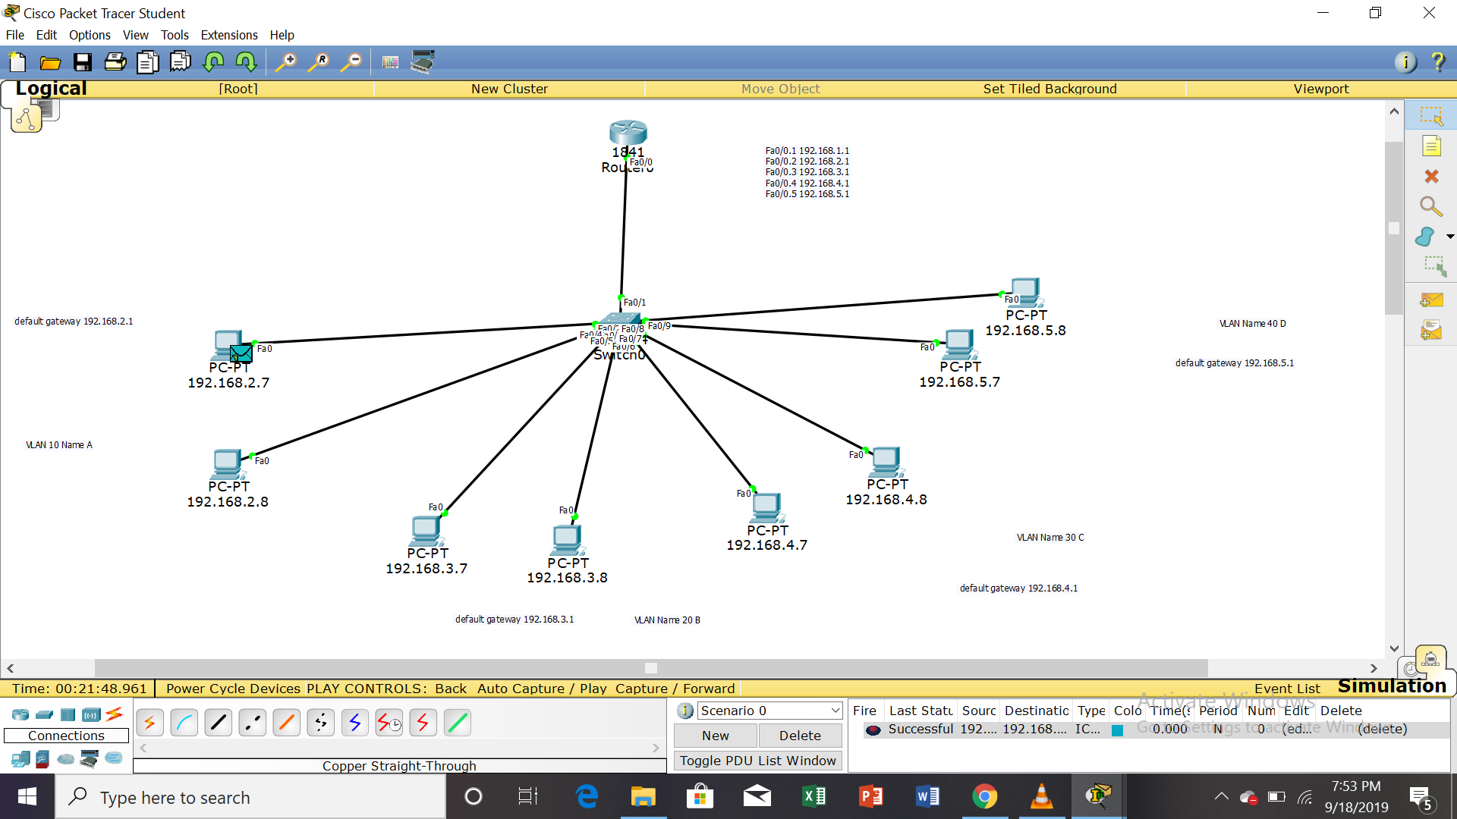

**Fig: Router with three VLANs.**

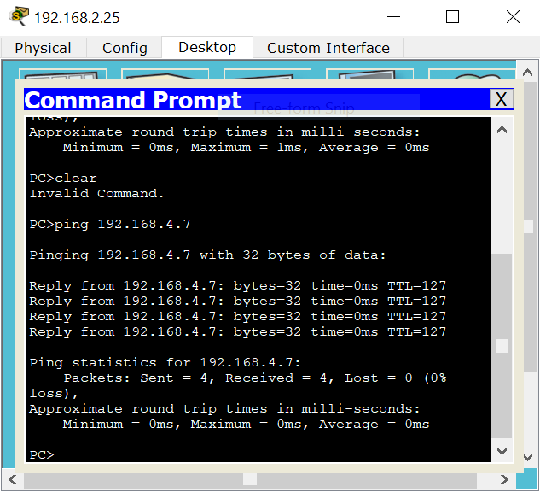

**Fig: Router with three VLANs output using ping command**

**Conclusion:** The experiment helped us to understand the use of router in VLAN connection as we can transmit data over different VLAN’s. But we have to be careful while connecting them as it is very sensitive.